Mount Olive Evangelical Lutheran Church, ELCA
211 Main Street, Mukwonago, WI 53149-1525
Ph: 262-363-8251 E-mail: mto@mountolive-elca.net
Web-site: www.mountolive-elca.net

July 2026

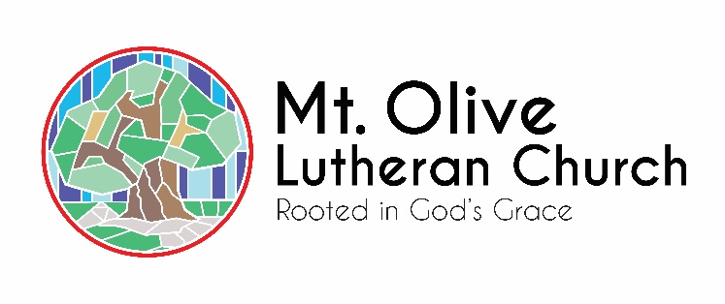

ALL ARE WELCOME

SUNDAY WORSHIP & HOLY COMMUNION:
Summer In-Person Worship & HC @ 8 & 9:30 a.m.
Our worship services will be livestreamed @ Facebook, and YouTube. Facebook stream also found on the home page of our website: www.mountolive-elca.net

OFFICE HOURS
Monday-Thursday 8 a.m. - 2 p.m.
Church Office: 262-363-8251
Email: mto@mountolive-elca.net

CHURCH STAFF
Pastor Steve Bogie
Office Phone: 262-363-8251
Cell Phone: 262-409-0743
Email: pastorsteve@mountolive-elca.net

Administrative Assistant
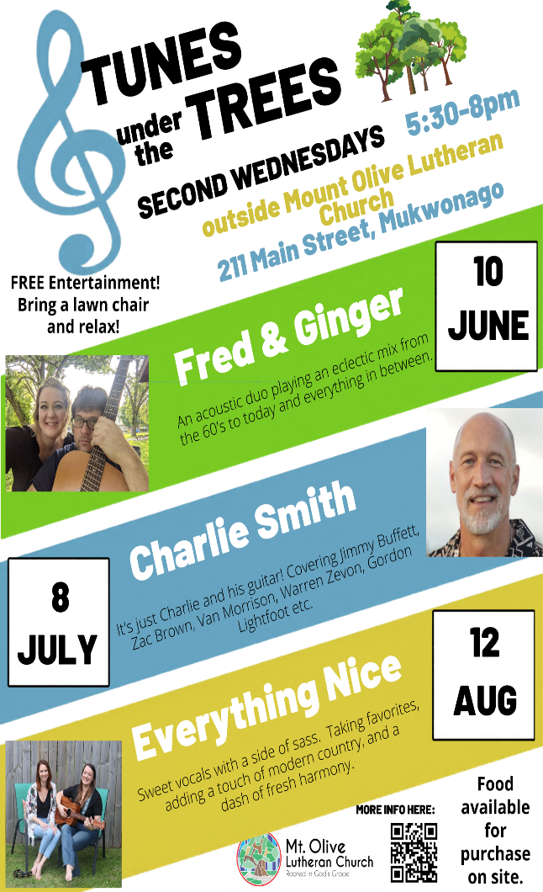
Debbie Wagner

Maintenance Housekeeping
David Gill Marie Sackett

Worship Accompanist/Praise Team Director
Deanna Kulow deanna.kulow@mountolive-elca.net

Sunday School Coordinator
Cindy Dobberke

AofB Coordinator
Cindy Dobberke 262-719-5711
cindy.dobberke@mountolive-elca.net

Prayer Chain
Betty Hinkelman 262-662-0205 or
Church office 262-363-8251

Websites
www.mountolive-elca.net
www.milwaukeesynod.org
www.elca.org

TUNES UNDER THE TREES

Join us on the second Wednesdays in June, July, and August from 5:30-8 p.m. outside on Mount Olive’s green space. Free entertainment! Bring a lawn chair and relax! Food available for purchase on site. Mark your calendars!

--July 8th – Charlie Smith – It’s just Charlie and his guitar! Covering Jimmy Buffett, Zac Brown, Van Morrison, Warren Zevon, Gordon Lightfoot, etc.

--August 12th – Everything Nice – Sweet vocals with a side of sass. Taking favorites, adding a touch of modern country, and a dash of fresh harmony
A MESSAGE FROM PASTOR STEVE

And he told them many things in parables, saying: “Listen! A sower went out to sow. And as he sowed, some seeds fell on a path, and the birds came and ate them up. Other seeds fell on rocky ground, where they did not have much soil, and they sprang up quickly, since they had no depth of soil. But when the sun rose, they were scorched, and since they had no root, they withered away. Other seeds fell among thorns, and the thorns grew up and choked them. Other seeds fell on good soil and brought forth grain, some a hundredfold, some sixty, some thirty. If you have ears, hear!”
Matthew 13:3-9 NRSV

Seeds of the Long Game

There’s something sacred about soil.
Amen!?

Over the time we have spent together, almost two years, we’ve begun the work of the short game of cultivating new ground for growth. We’ve pulled weeds that choke out life. We’ve tilled the land, turning over what has been settled and compacted. We’ve prepared the soil, making room for something new to take root.

But here’s the truth every gardener knows: preparing the ground is only the beginning.

Planting seeds is an act of faith that takes time.

Ministry often tempts us toward the “short game,” quick results, visible impact, immediate growth. And yes, there are moments when we do see something sprout quickly. A conversation that brings comfort. A gathering that sparks joy. A need that is met right away.
But most of ministry? It’s the long game.

Amen!?

It’s the quiet, patient work of planting seeds of mercy, grace, and love; trusting that God is at work beneath the surface long before anything breaks through the soil. It’s showing up and being stubborn, even when we don’t yet see the fruit. It’s believing that what is planted in faith will, in time, grow into something greater than we can imagine.

We know that seeds don’t grow overnight. They require care; consistent, gentle, faithful care. They need sunlight and water, but also time. They need a grower willing to tend them with patience, to protect them in their vulnerability, and to trust the process of growth.

The same is true for the seeds we plant in ministry.

When we offer kindness, when we extend grace, when we embody Christ’s love in small and quiet ways, we are planting seeds. Some will take root quickly. Others may lie dormant for a season, or longer. But none of it is wasted.

God is the one who brings the growth.

So, we keep planting.
We keep tending.
We keep trusting.

And by God’s grace, what is being planted now will one day flourish in ways we may never fully see, but will forever be part of the story God is telling through this community.

Let us be faithful seed-planters; committed not just to what grows today, but to what will grow for generations to come.

In Jesus name!
Steve Bogie Pastor

-------------------------------------------------------


MOUNT OLIVE
MID-YEAR MEETING

Enjoy an ice cream sundae along with an update at Mount Olive’s mid-year gathering of the congregation. Please accept this treat as a “Thank You” for sharing your gifts of time, talent, and possessions, plus an opportunity to check in with your Mount Olive family.

Sunday, July 19th, following the 9:30 service

Ice cream will be served following each service. Come along and see what amazing things God is doing at Mount Olive!

PRAISE BAND

Mount Olive is beginning an exciting new chapter in worship with the launch of a praise band during the second service on the fourth Sunday of the month! At its heart, music and ministry are built on relationships and joy—creating music that connects us to one another and to God, inspiring people to engage their faith.

We invite you to support this new ministry—and if you feel called, to be part of it. Bring your gifts. Bring your voice. Let's grow something meaningful together in Jesus' name.

------------------------------------------------------
NATIONAL YOUTH GATHERING
From Pastor Steve

Dear people,
I’m excited to share an incredible opportunity for the youth of Mount Olive. The opportunity to participate in the 2027 ELCA Youth Gathering in Minneapolis, centered around the theme “Imagine More.”
Held every three years, the ELCA Youth Gathering brings together thousands of high school students and adult leaders from across the country for a meaningful week of faith formation, worship, service, and community. This event is thoughtfully designed to help young people grow in their relationship with God, build lasting friendships, and experience the wider church in powerful ways.
Throughout the Gathering, participants will engage in large-group worship, interactive learning experiences, service projects, and small-group time with trusted adult leaders. Every aspect of the event is structured to be safe, supportive, and spiritually enriching.
Opportunities like this often-become milestone moments in a young person’s faith journey: times when they begin to take ownership of their beliefs, ask important questions, and discover how they are uniquely called to live out their faith.
As a congregation, we will travel together, ensuring strong leadership, clear communication, and a supportive environment every step of the way. More details about cost, fundraising opportunities, and registration will be shared soon.
I would love for the youth of this congregation to be part of this experience. If you have any questions or would like to learn more, please don’t hesitate to reach out.
Thank you for your partnership in nurturing the faith of our young people.
Grace and peace,
Pastor Steve Bogie
*Here is a writeup for the 2027 ELCA National Youth Gathering provided by their website.
2027 ELCA NATIONAL YOUTH GATHERING

Every three years, thousands of high schoolers and their adult leaders from across the ELCA come together for the ELCA Youth Gathering. It’s not just an event but a movement in which faith ignites and community comes alive. Through inspiring speakers, experiential learning and transformative connections, young people experience the church in bold, unforgettable ways. Each night, participants share a unique faith experience through high-energy worship and powerful storytelling. The Gathering is an opportunity to ask big questions, grow in faith and be part of something bigger than yourself. Are you ready to join the movement?

Our mission:

The ELCA Youth Gathering, a unique community by size and scope, exists to accompany young people in their faith journey. Through experiential learning, worship, and intentional community, participants will be both affirmed and challenged in their faith.

Our vision:
Inspire a movement of young people to boldly live out their faith.

Our values:
Faith: We root everything we do in God’s undeserving grace, creating space for young people to grow in faith, wrestle with big questions and be transformed by the gospel.

Belonging: Every young person is created in God’s image and celebrated as a whole person — questions, complexities and all. The Gathering is a place where all people belong and are seen, valued and embraced in Christ’s love.

Connection: Through shared experiences, the Gathering creates connections — within congregations, across the ELCA and with the wider world — reminding young people that they are part of something bigger than themselves.

Curiosity: We cultivate a spirit of curiosity, encouraging young people to ask bold questions, explore new perspectives and expand their understanding of faith in action.

Inclusion: We commit to creating an equitable, accessible and just environment where every young voice matters. We believe that God’s creation and love are without limit and that our work to embrace our neighbor expresses God’s inclusionary love.

Leadership: We believe that young people are not just the future of the church but leaders here and now. The Gathering empowers young people to discover their gifts, grow in confidence and step into courageous leadership in their churches, their communities and the world.

History of the Gathering
Young Lutherans have been gathering for more than a hundred years! The Lutheran denominations that merged to create the ELCA all had rich traditions of bringing their young people together. We’ve gathered in places from Los Angeles to Boston under such themes as “Called to Freedom” and “Jesus, Justice, Jazz,” with speakers ranging from the Rev. Martin Luther King Jr. to the Rev. Nadia Bolz-Weber.

WILD CHURCH IS COMING
TO MOUNT OLIVE

Something new—and beautifully ancient—is coming to Mount Olive.

On Sunday, July 26th, at 9:30 a.m., we will gather for Wild Church, a unique worship experience that invites us to encounter God not only through Word and sacrament, but also through creation itself. Rooted in the belief that God speaks through both scripture and the natural world, Wild Church creates space to listen, pray, and worship outdoors.

To give this experience the time and space it needs, we will hold one combined service at 9:30 a.m. that day.

This will be a Jesus-centered gathering—just in a different setting. Expect meaningful worship, intentional time in nature, and a chance to experience God in a fresh way.

What to Bring:
- A lawn chair or blanket for seating
- Water to stay hydrated
- Bug spray and sunscreen
- Comfortable clothing and shoes for being outdoors

Come curious. Come comfortable. Come ready to encounter God in the wild.

-------------------------------------------------------

GATHER AT NIGHT

You've heard of Coffee with Dudes, well, Mount Olive has another new opportunity to gather and connect for ladies! No official name yet, but for the moment let's call it...Gather at Night.

Where? The Back Porch Bar, 204A S. Rochester St., Mukwonago- next to Badger Burger.
When? Tuesday, June 30, 6:30-8:00 PM. See you there!

PS Are you interested but can't make the first Gather at Night? Please contact Cindy at cindy.dobberke@mountolive-elca.net or Debbie in the MTO office for more details.
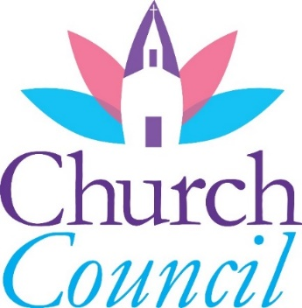
COUNCIL CORNER

This is just a little note to announce that our mid-year congregational meeting will be July 19, 2026, following the 9:30 AM service. In true Lutheran tradition, we will have treats, coffee, and other goodies.

I believe we started having mid-year congregational meetings when we began the call process in 2022 as a way to update the congregation on the status of the call process and to allow members to ask questions and provide input. We have also used the mid-year meeting to update the congregation on projects, committee activities, finances, and other matters. While we try our best to keep the congregation membership informed with weekly announcements and the monthly newsletter, the best communication is when there is a two-way dialog (and treats).

This year, one topic will be our financial status. In January, at our year-end annual meeting, we approved a deficit budget that reflected expenses exceeding expected income by approximately $53,000. In the short term, a deficit isn’t terrible if the organization has cash reserves to fund the deficit. Obviously, an organization cannot operate with annual deficits forever.

Based on our financial performance over the last 5 months, I believe we will end the year very close to the budget deficit. The congregation's cash reserves stand at just over $100,000, which means we can absorb our current deficit spending pace for roughly two years. In the spirit of transparency, part of the agenda for the mid-year congregational meeting on July 19th will be to discuss:

- Our mid-year financial statements
- Our forecast for the full year 2026
- Ideas for reducing the deficit

The simple math is that to reduce or eliminate a deficit, an organization has two options… increase income and/or reduce expenses. Obviously, there are multiple ways to accomplish both. As treasurer, I will do my best to explain our current financial position. What I really look forward to is the opportunity to hear questions and ideas from the membership.

The mid-year meeting is intended to be a two-way communication where all attendees can ask questions and contribute their thoughts. We are all in this together. Mount Olive has been serving the community for over 100 years, and I am confident that we all want our ministry to continue for 100 more and beyond.

Simply put, please plan to attend the mid-year congregational meeting.

Dennis Martin
Council Member and Treasurer

-------------------------------------------------------

PLASTIC COLLECTION


Starting in 2026, Trex has reconfigured its community-challenge recycling program. Instead of a yearly reward, they are now offering a quarterly drawing for groups that collect enough plastic to qualify.

Congratulations! Our first quarterly submission has been approved. This achievement has earned MTO an entry into the Trex Recycling Program quarterly lottery. So far, for the second quarter of 2026, we have collected 254 pounds!

SERVICE OPPORTUNITIES

Have you ever wondered what it’s like to serve in worship as a reader, usher, or assistant minister? These aren’t just roles to fill—they are pathways into a deeper, more intentional encounter with God.

When you serve as a reader, you don’t just speak words; you give voice to the living Word. Scripture moves from page to people, and in that moment, something mysterious and holy happens: God’s voice meets human breath, and the Word becomes alive again in the hearing of the community. You are not just reading; you are participating in God’s ongoing conversation with God’s people.

As an usher, you help create sacred space. Long before a word is spoken, the Spirit is already at work in welcome, eye contact, a smile, a simple “good morning.” In these small, faithful acts, you embody Christ’s hospitality; making room not just in a building, but in hearts. You help set the stage for people to encounter grace, often before they even realize they need it.

As an assistant minister, you step into the rhythm and flow of worship itself; helping lead prayers, guide communion, and hold space for the movement of the Spirit among us. Here, you don’t just witness grace, you help carry it. In spoken prayers and shared bread, you become part of the way God meets people in tangible, real, and life-giving ways.

In each of these roles, something profound unfolds: you’re not just participating in worship, you’re being formed by it. God works through your voice, your presence, your hands, and at the same time, God is shaping your heart. Again and again, it is in the act of serving that we become most aware of God’s presence, not just around us, but within us and moving through us.

Come talk to Pastor Steve to learn more; or better yet, Pastor Steve may into this experience with the divine. You may find that in offering yourself in these simple but sacred ways, you encounter the divine in ways you never expected.


COFFEE WITH DUDES
JULY 21st

Looking for a relaxed midweek reset and some good conversation? Coffee With Dudes is Pastor Steve’s monthly care team ministry for men, where guys can drop in, grab a cup of coffee, and connect in a laid-back setting.

Held every third Tuesday of the month from 10 a.m. to 12 p.m. at Sol de Mexico, it’s an open time for conversation, encouragement, listening, and support—no agenda, no pressure, just real talk over coffee.

Whether you stay for 10 minutes or the full two hours, you’re welcome to come as you are and be part of a community that shows up for one another.

------------------------------------------------------


Free Pantry/Kitchen Kupboard Food Pantry

Located in the lower level of Mount Olive, we are grateful for the Kitchen Kupboard Food Pantry and its ministry to our community's needy. The Pantry is open on select Thursday mornings or by appointment.

Also, Mount Olive’s Little Free Pantry is located outside the lower doors of MTO and is available 24 hours a day/7 day a week. The Little Free Pantry is kept stocked by the Kitchen Kupboard Food Pantry team. Please note the items listed below and drop off in the basket marked Food Pantry, located in the Narthex: Mac & cheese boxes, potato and noodle boxes, dry goods, cereal, shelf-stable milk, granola bars, tuna, canned soups, canned fruits and vegetables, laundry soap, and deodorant.

They could use the following items: pickles (not relish), olives, canned potato salad, mustard, and mac and cheese, bottled juice (orange, grape, and apple)

SERVICE TEAM UPDATE

The Service Team is starting a pilot program of frozen meals for those in need. Please contact the church office at mto@mountolive-elca.org or (262) 363-8251 if you have a need and the office will coordinate. All requests are confidential.

More details will be available in the upcoming weekly bulletin and emails. Contact Deb Barnes for questions or information.

“Fill the Bag”
Outreach for Hope Emaus’
School/Kids Kits

The purpose is to help Emaus’ ELCA students by donating much-needed supplies for the EASY (Emaus’ After School for Youth) and Neighborhood Camp programs. Your Mount Olive Service Team has set a goal of 50 bags. Lists and tags for individual items are located on the easel in the Narthex. Collection dates are: July 5th & 12th.

Thank you for supporting students and families in our community.

School/Kids Kit (per bag)
Each canvas bag should include the following items:
- 1 canvas bag with handles (provided)
- 1 box of 12 colored pencils
- 1 two-pocket folder
- 1 pair round-tip scissors
- 1 12-inch ruler
- 1 handheld pencil sharpener
- 1 large pink eraser
- 6 unsharpened pencils
- 1 box of 24 crayons
- 1 pencil pouch
If you have any questions, please contact Sara Salmela.

🌷 Mount Olive Walking Group 🌷
Thursdays
10 –11 a.m.
(Weather permitting)

💛 Move your body.
💛 Lift your spirits.
💛 Connect with friends.

Even a 30-minute walk can boost energy, sharpen your mind, and brighten your day!

Come as you are. Walk at your own pace. Enjoy good company and great conversation.
Everyone is welcome! Join us and step into joy!
— Pastor Steve Bogie

-------------------------------------------------------


LOVE ONE ANOTHER
MOUNT OLIVE’S CARE TEAM

Every one of us – even those of us who are fiercely independent – needs care and compassion from others. There are times in our lives when we feel able to give this support and other times when we have to humble ourselves to receive a caring hand.

We are in the beginning stages of forming a care ministry at Mount Olive. This endeavor will best be described as a social ministry. No professional services will be provided, just opportunities for human connection. We want to build a network of care and belonging within the family that is our congregation.

If you are currently finding life a little challenging, perhaps due to age or health issues, please call the office to express your interest in this new ministry. If you are being called to reach out and provide care and support to others, please do the same. Questions are welcome; call Pastor Steve or Betty Arntson.
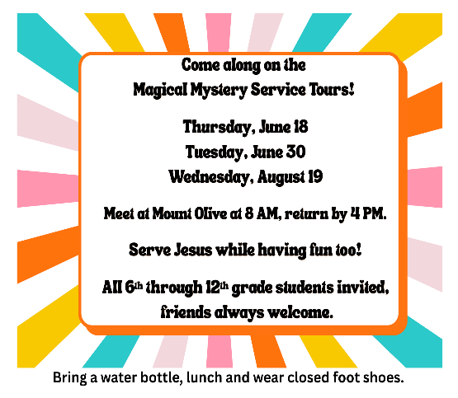
Mount Olive Faith Explorers

Our 2026 High School Graduates:
- Kaitlyn Elizabeth Fick… graduated from Waterford Union High School and plans to attend Carthage College to study musical theatre with a minor in Spanish.
- Rayna Marie Jellish…graduated from Mukwonago High School and plans to attend Rice University to study bioengineering & psychology.
- Jack William LaFreniere…graduated from East Troy High School and plans to attend UW-Platteville to study software engineering.
- Karson Rudolph…graduated from Mukwonago High School and plans to attend UW-Madison to study engineering.

Our 2026 College and Post-College Graduates:
- Emma Husted…earned a Bachelor of Science degree from UW-Madison in industrial engineering and is working as a Project Specialist at Hooper Construction in DeForest.
- Emma Libecki…earned a Bachelor of Science degree from Carthage College with a double major of chemistry and education, and will be teaching high school chemistry.

AoB and High School Summer Opportunities:
Mystery Mini- Mission Trips…
Pastor Steve and Cindy invite our 6th through 12th grade students to one-day-long Magical Mystery Tours. We will explore faith together while serving others and having fun. In July and August, we will join with youth from Vernon Lutheran for our mystery days. More details will be revealed as we near the dates, but please mark the following on your calendar and plan to attend from 8 AM to 4 PM:
- Tuesday, June 30th, sign up by Wednesday, June 24th
- Wednesday, August 19th, sign up by Wednesday, August 12th
- Friends are welcome too!
- If transportation is an issue, just let us know, and we will do our best to make arrangements for pick up and/or drop off at your home.

And as always, if you’d enjoy working with our younger set during the week of VBC (August 3-7, 1-4 PM), please let Cindy or Pastor know! We’d love to have you as part of that week!

-------------------------------------------------------


MOUNT OLIVE
VACATION BIBLE CAMP…

Mount Olive Vacation Bible Camp dates are set…

We will explore God’s Good Creation

August 3rd through 7th from 1 - 4 p.m.!
(Note the change of time!)

All are welcome to join in the faith and fun! 6th graders and older are invited to assist as guides or junior guides.
Registration forms are included elsewhere in this newsletter.
GRIEF SUPPORT

Grief can and does enter our lives in a huge variety of ways. You are invited to attend this group for very informal discussions in a safe place and supportive environment. Please feel free to call if you would like further information, login Zoom info, or have any questions: Betty Hinkelman.

The meeting is on the third Thursday of each month, beginning at 12:30 p.m. Attendance is at Mount Olive in the Fellowship Hall or on ZOOM, whichever you are comfortable with. They will meet next on Thursday, July 16^{th,} at 12:30 p.m.

-------------------------------------------------------


INVITATION TO PRAY

You are invited to come and pray as we come together for contemplative prayer on the labyrinth. Join me for prayer with Holy Scripture using the ancient method of Lectio Divina, or you may choose to come for Centering Prayer, a prayer practice with silence as we simply rest in God’s presence for a twenty-minute period of time. No experience is needed for either of these quiet methods of praying. A simple desire to be with God is all that you need to bring.

I invite you to come at any of these following times for this prayer opportunity (schedule of dates & times below). If you want to participate but need a different time slot or if you have any questions or would like further explanation, please feel free to call any time. I look forward to praying together. Betty Hinkelman.

Monthly Schedule of Prayer Opportunities:
- Lectio Divina: 1st & 3rd Monday of each month…beginning at 11 a.m.
- Centering Prayer: 2nd & 4th Monday of each month…beginning at 11 a.m.

-------------------------------------------------------

WEDNESDAY NIGHT &
SUNDAY MORNING BIBLE STUDY

Wednesday Night Bible study meets at 6:30 p.m. on Wednesdays in the Fellowship Hall during the school year.

The Wednesday night class welcomes people with all levels of Biblical knowledge. You need not be a Bible “expert.” Furthermore, 25% of the class are members of congregations other than Mount Olive, so feel free to invite your friends and neighbors to attend with you. For more information, contact Dwight Cruikshank.

The Sunday adult education group meets from 9–9:50 a.m., between the worship services during the school year. This next educational year, we will meet in the Fellowship Hall (except when other activities are scheduled for that space) to accommodate more people and make it easier to have snacks or beverages.

Contact Laura Conry with any questions.


DON’T MUNCH ALONE BUNCH (DMAB)


Come and join us when Don’t Munch Alone Bunch (DMAB) meets on Tuesday, July 14th at 11:30 a.m., at Chen’s Kitchen in Mukwonago.

DMAB is a fun fellowship activity, inviting all ages to meet, eat, and share together. Bring a friend if you’d like. There’s no need to make a reservation, because we’ll save a place at the table for you.

If you’d like more information, please call Bruce Gunderson. We hope you will join us.

-------------------------------------------------------

THE KNOTTY KNITTERS…

Are a group that invites anyone interested to join them in the church library on Friday mornings from 10 a.m. to 12 noon to knit prayer shawls and such, share stories, and have goodies. All are welcome…no experience necessary.

Please note that the Knotty Knitters are taking
a summer break…
watch for more details come early September.

If you have questions, please call Betty Hinkelman or Inge Adams.

-------------------------------------------------------

LADIES BOOK CLUB

Mount Olive’s Ladies Book Club will meet next on Tuesday, July 14th, at 2 p.m., @ Mount Olive. They will be discussing “Ladies of the Lake” by Cathy Gohlke.

Our book club always welcomes new members. Join us to enjoy interesting books, discussions, and fun. Reading enriches our minds, hearts, and spirits.

All are welcome…even if you haven’t read the book! If you have any questions, please contact Diane Dickey or the church office at 262-363-8251.
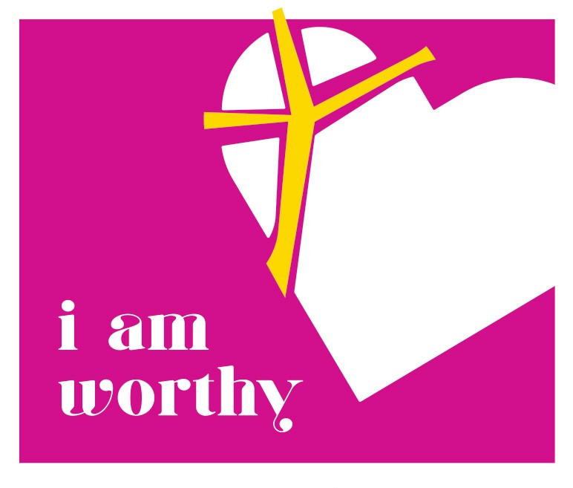
GATHER FAITH EXPLORATION GROUP

Join us as we begin our summer bible study!
Tuesday, July 21st,
9:30 a.m. –
MTO Fellowship Hall
Please contact the church office if childcare
is needed and to be added to our group email list.
Zoom link is available.
Summer 2026: “I am worthy,”
by the Rev. Sara Olson Smith

This summer, Women of the ELCA participants will gather in Des Moines, Iowa, under the theme “I am worthy.” When Nobel Peace Prize winner Leymah Gbowee spoke in 2017, she invited WELCA participants to reclaim space for women and girls to lead and love in bold ways. This three-part Bible study will help us to define who we are, what we can be, and what we do in the world, in light of our God-given giftedness, identities and relationships.

(July 2026) “I am more than one thing: Honoring our many identities.” In her TED talk, “The Danger of a Single Story,” Chimamanda Ngozi Adichie names this truth: We are much more than one thing. All of us have intersecting identities, roles and responsibilities. Beyond our ethnicity, the color of our skin or our birthplace, we may also be a sister, a mother, a daughter, a friend. We have various vocations, hobbies and joys.

In this session, we’ll explore how the multiple identities of several women in Scripture shape their faithful living. Esther is not just a queen, but a niece, as well as part of an oppressed community of faith. Ruth is so much more than just a widow. Mary Magdalene has more identities than can fit within the allowed word count of this paragraph. So do you!
-------------------------------------------------------
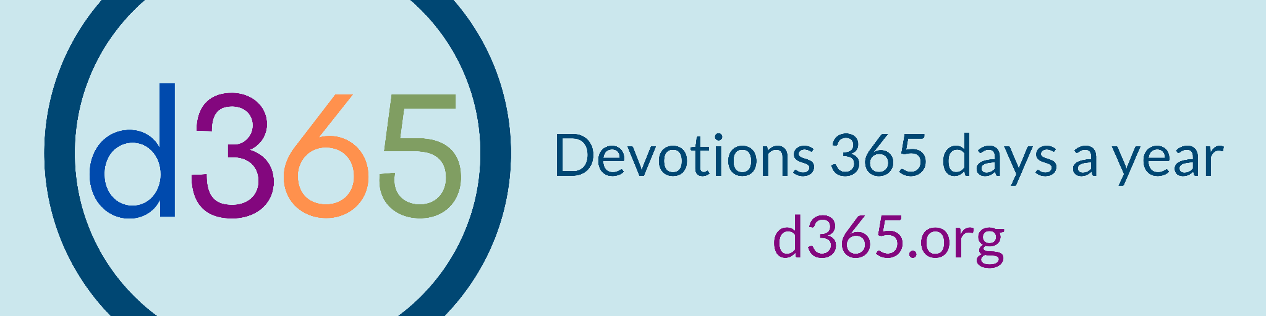
Are you looking for a daily devotional? This easy-to-use resource (including background music!) is designed for youth and adults.

Check it out at d365.org, or follow them on Facebook. The ELCA is a partner in this ecumenical resource.
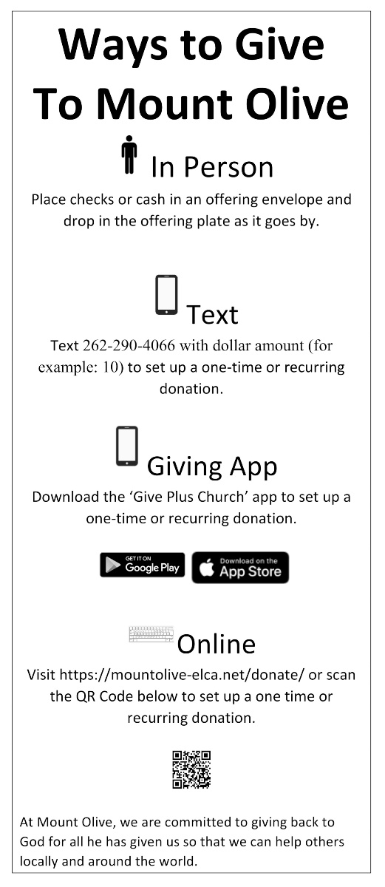
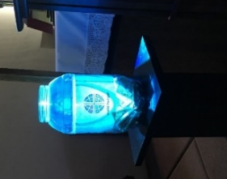
ELCA World Hunger

The Hunger Jar appreciates the jingling of our change! Our donations for 2026 are -- $32.20.

If you are collecting your change at home for ELCA World Hunger during our time of online worship, please consider sending in a check or bringing the funds into Mount Olive so that they can be deposited. We will send them out into the world as a witness to our faithfulness during this critical time.

-------------------------------------------------------

MONTHLY FINANCIAL STATUS
from the Bookkeeper

 | May  2026 Actual | May  2026 Plan
General Income | $143,482 | $112,292
General Expenses | (133,495) | (124,365)
Surplus/(Deficit) | 9,987 | (22,073)
General Fund  Cash Balance | 3,718

OFFERING/DONATION UPDATE

You can also share your financial gifts by:

1. Mailing your offering to the office:
Mount Olive Lutheran Church
211 Main Street
Mukwonago, WI 53149

2. Donating via our webpage: Make a one-time or
recurring donation. Any recurring donation will require you to register if you don’t already have a Simply Giving account. Contact Debbie in the office if you need any help with the webpage…262-363-8251.

Thank you for your ongoing support to the ministries of Mount Olive.
Dennis Martin
Treasurer
Finance and Stewardship Team

Find yourself without cash,
please use the above QR code to give online.

VARIOUS TEAM/GROUP UPDATES

Group Meeting | Time and Frequency | Contact person
Wednesday Text Study | 9:30 a.m. every Wednesday @ Mount Olive & via Zoom | Church Office  mto@mountolive-elca.net
Knotty Knitters | 10 a.m. every Friday | Inge Adams  Betty Hinkelman
Gather Faith Exploration Group: Meeting in person & via Zoom | 9:30 - 11 a.m. on the second Tuesday of each month | Cindy Dobberke  Cindy.dobberke@mountolive-elca.net
Sunday Morning Adult Bible Study | Sundays @ 9 a.m. | Laura Conry
Wednesday Evening Bible Study | Wednesday evenings @ 6:30 p.m. | Dwight Cruikshank
Don’t Munch Alone Bunch | 11:30 a.m. on the second Tuesday of each month | Bruce Gunderson
Lectio Divina: Meeting in person & via Zoom | 11 a.m. on Mondays – July 6th & 20th | Betty Hinkelman
Centering Prayer: Meeting in person & via Zoom | 11 a.m. on Monday, July 13th & 27th | Betty Hinkelman
Grief Support: Meeting in person & via Zoom | Meeting time varies; please contact Betty or see page 8 | Betty Hinkelman
Service Team | Meets on the second Monday of every month at 9:30 a.m. | Deb Barnes
Food Pantry Donations | Donations can be made directly to the pantry as follows: July 9^{th,} 23rd, & 30th -- 9:30-11:30 a.m.; contact Carole Hahl @ 262-662-3953 | Church Office  mto@mountolive-elca.net
Aluminum Can Donations | Please continue collecting aluminum cans for our HS students to support their annual youth accompaniment trips; your donations can be dropped off at a later date! | Church Office  mto@mountolive-elca.net


ALUMINUM CAN RECYCLING
at Mount Olive!!

Yep, our High School students are still doing it! Want to help? Be sure to save your cans and drop off at the rear door at Mount Olive so that we can send the cans on their way to the recyclers. It’s a great way to save the environment AND our help our High School students when they head off on their next big Accompaniment trip!


PRAYING FOR MEMBERS
at Mount Olive Lutheran Church

First of all, then, I urge that supplications, prayers, intercessions, and thanksgivings be made for everyone. I Timothy 2:1

It seems to me that no one is so poor as an individual for whom not a single soul is praying, and has no one who takes him or her personally and persistently to God in prayer. O. Hallesby, Prayer

“Praying for Every Member” is sponsored by Prayer Ministry. By using this monthly newsletter insert, we will pray unceasingly for each other.

7/1 Jason, Jennifer, Logan, Alden, &
Isabella Wienke
7/2 Shannon, Nathaniel, Anthony, Ciara, &
Arkadia Wilcher
7/3 Mary Winchowky
7/4 Matthew, Becky, Logan, & Haley Woessner
7/5 Russell Wright
7/6 Phyllis & Emily Zaddack
7/7 Inge Adams
7/8 Adam, Kiana, Bailey, & Brooke Adcock
7/9 Christina, Johnathan, Cassandra, &
Nathaniel Altenburg
7/10 Jason & Kim Anderson
7/11 Jerry & Betty Arntson
7/12 Deb & Thomas Barnes
7/13 Mark, Tracy, Hunter, & Kasey Bischmann
7/14 Karolina Bittner
7/15 Pastor Steve, Heather, Olivia, & Ila Mae Bogie
7/16 Benita Breedlove
7/17 Lucas, Annie, James, & Porter Breytung
7/18 Robert & Lynn Brueggeman
7/19 Aaron, Joya, Addison, & Micah Budd
7/20 Lukas, Sarah, Emma, & Zachary Buettner
7/21 Linda and Cassidy Burie
7/22 Jeffory & Jennifer Burke
7/23 Cody, Kevin, & Harper Busch
7/24 Rick, Kristin, Hannah, & Olivia Carey
7/25 Bill & Lori Carpenter
7/26 Nicole Nussbaum
7/26 Dennis Case
7/27 Glenn Case

7/28 Scott, Erin, Cason, Brantley, & Aubrey
Christensen
7/29 Nicholas, Kristi, Archer, & Lilah Ciesinski
7/30 Cheryl Connor
7/31 Laura Conry

JULY BIRTHDAYS…

Thomas Sperstad 7/3
Linda Filler 7/4
Gary Graczyk 7/5
Grayson Pearce 7/7
Jason Anderson 7/8
Chase Tauriainen 7/10
William Horne 7/11
Zackary Buettner 7/13
Jeri Franz 7/13
Eleanor LaFreniere 7/14
Heather Bogie 7/15
Diane Jackson 7/16
Mila Stieber 7/17
Kay Vietzke 7/17
Matthew Fick 7/19
Roxanne Janisewski 7/20
Kim Martin 7/21
Peyton Stigler 7/21
Jeffory Burke 7/24
Grace Graczyk 7/25
Bill Graser 7/28
Lisa Neidhold 7/28
Bill Ross 7/28
Mitchell Roehl 7/29
Patricia Vandehey 7/29
Connor LaFreniere 7/30
Lila Schemm 7/31

JULY ANNIVERSARIES…

Steve & Heather Bogie 7/7
Molly & Andrew Riehle 7/7
Christina & Raymond Altenburg 7/20
Betty & Jerry Arntson 7/21
Kevin & Deanna Kulow 7/25
Deborah & Richard Struck 7/31

COUNCIL CORNER
Council Member | Phone Number | Email Address
President Mike Zaddack
Vice President Scott Shuda
Secretary Linda Burie
Treasurer Dennis Martin/Finance/Stewardship
Inge Adams
President Cindy Dobberke
Larry Redlin
Cheryl Shanovich
Duane Thornton
Pastor Steve Bogie | 262-409-0743 | pastorsteve@mountolive-elca.net
Adopted Council minutes are posted on the Council bulletin board for your review. Please feel free to contact any Council member listed above with any new ideas or caring concerns regarding Mount Olive. Please remember all our Council Members in your prayers.

GET CONNECTED
ACTS Team | Betty Arntson
Administrative Assistant | Debbie Wagner | 262-363-8251 | mto@mountolive-elca.net
Adult Forum (Sunday mornings) | Laura Conry | 262-751-9410 | lconry334@gmail.com
Altar Guild | Eva Schindhelm
Gather Bible Study (monthly) | Cindy Dobberke
Bookkeeper | Doug Bue |  | finances@mountolive-elca.net
Coffee Fellowship | Debbie Wagner | 262-363-8251 | mto@mountolive-elca.net
AoB Coordinator | Cindy Dobberke | 262-719-5711 | cindy.dobberke@mountolive-elca.com
Custodial | Debbie Wagner | 262-363-8251 | mto@mountolive-elca.net
Don’t Munch Alone Bunch (DMAB) | Bruce Gunderson
Financial Secretary | Debbie Wagner | 262-363-8251 | mto@mountolive-elca.net
Grief Support Group | Betty Hinkelman
Knotty Knitters | Betty Hinkelman  Inge Adams
Ladies Book Club | Diane Dickey
Memorials | Angela Porter
Mt. Menu Coffee | Debbie Wagner | 262-363-8251 | mto@mountolive-elca.net
Praise Team Director | Deanna Kulow |  | deanna.kulow@mountolive-elca.net
Prayer Chain | Betty Hinkelman
Service | Deb Barnes
Sunday School Coordinator | Cindy Dobberke | 262-719-5711 | cindy.dobberke@mountolive-elca.com
Thrivent Financial for Lutherans Congregational Advocate | Matt & Julie Fick
Wednesday Night Bible Study | Dwight Cruikshank

THIS WEEK AT MTO

Did you know that a weekly email is sent out each Wednesday entitled “This Week at MTO.” Each weekly email contains the following types of info: special messages, Mount Olive’s calendar for the coming week, and any other events that are happening at Mount Olive over the next week or so. If you are not currently receiving this email, please let the church office know your email address, and we will add you to the circulation list. Or sign up on our website at: www.mountolive-elca.net. Don’t miss out! PLEASE LET US KNOW…If you, a family member, or a friend would like to have a visit from the pastor, please notify the church office or Cindy Dobberke. We rely on you to keep us informed so that our ministry with you can continue: 262.363.8251 or mto@mountolive-elca.net.

Sun  JULY 2026  EMBER 2021 | Mon | Tue | Wed | Thu | Fri | Sat
 |  |  | 1  9:30am Weekly Text Study  6:30pm Women’s AA Mtg | 2  10am MTO Walking Group | 3 | 4 4th of July
5  8am Worship & HC  9:30am Worship & HC  7:30pm Alanon* | 6  11am Lectio Divina | 7 | 8  9:30am Weekly Text Study  1pm Worship Team Mtg  5:30-8pm Tunes Under the  Trees – Charlie Smith  6:30pm Women’s AA Mtg | 9  9:30am MCC Food Pantry*  10am MTO Walking Group | 10 | 11
12  8am Worship & HC  9:30am Worship & HC  7:30pm Alanon* | 13  9:30am Service Team  11am Centering Prayer | 14  10am Muk Crazy Quilters*  11:30am DMAB Lunch  @ Chen’s Kitchen  2pm Ladies Book Club | 15  9:30am Weekly Text Study  6:30pm Women’s AA Mtg | 16  10am MTO Walking Group  12:30pm Grief Support  Group  1pm Muk Crazy Raffle  Quilt Committee* | 17 | 18
19  8am Worship & HC  9:30am Worship & HC  10:30am MTO Mid-Year  Congregational Meeting  7:30pm Alanon* | 20  11am Lectio Divina | 21  9:30am Gather Faith  Exploration Group  10am Coffee with Dudes  @ Sol de Mexico | 22  9:30am Weekly Text Study  5:30-8pm Larry Redlin FH  5pm Adult Ed Summer  Planning Session  6:30pm Women’s AA Mtg | 23  9:30am MCC Food Pantry*  10am MTO Walking Group | 24 | 25
26  10am Outdoor Worship &  HC/Wild Church  7:30pm Alanon* | 27  11am Centering Prayer | 28 | 29  9:30am Weekly Text Study  6:30pm Women’s AA Mtg | 30  9:30am MCC Food Pantry*  10am MTO Walking Group | 31
MOUNT OLIVE EVANGELICAL LUTHERAN CHURCH Telephone: (262) 363-8251
211 Main Street, Mukwonago WI 53149-1525 www.mountolive-elca.net Email: mto@mountolive-elca.net


